Classification Algorithm:
SVM Grid:

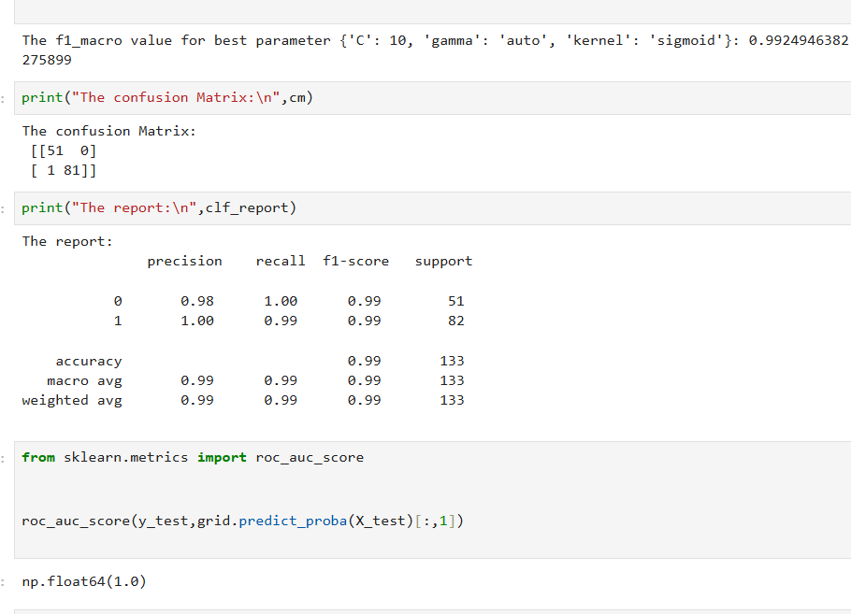

In SVM got 0.99 accuracy

Decision Tree Grid:

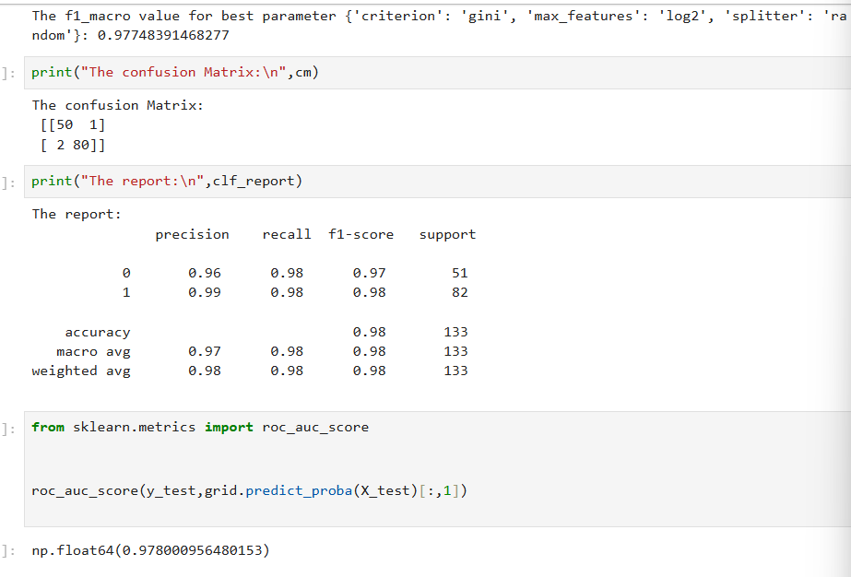

In Decision Tree Grid:
Got 0.98 accuracy

Random Forest Grid

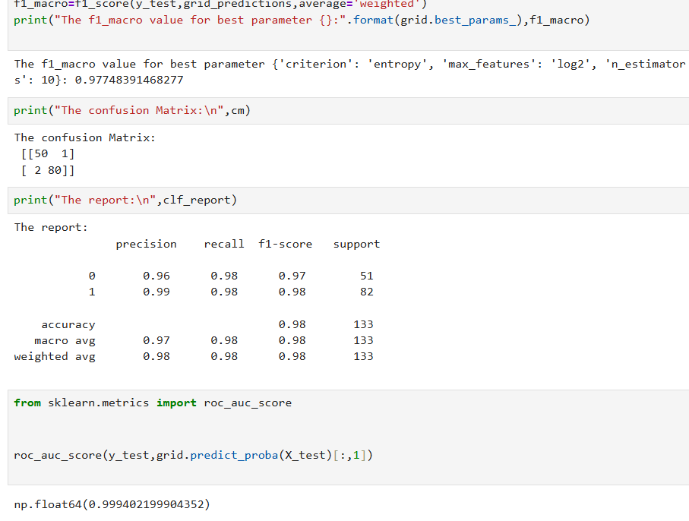

In RandomForest Grid:
Got 0.98 accuracy

LogisticRegression Grid:

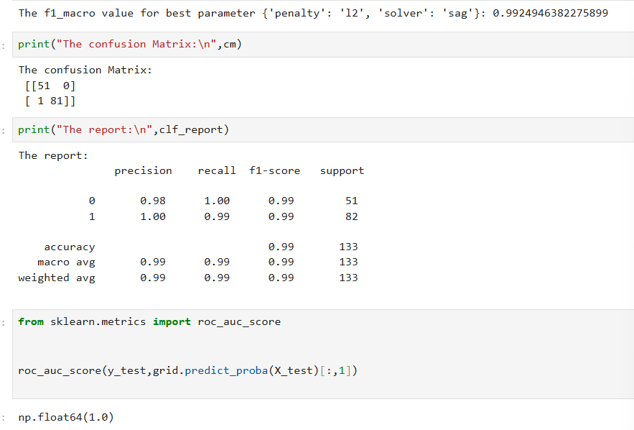

In Logistic Regression Grid:
Got 0.99 Accuracy

KNN Grid:

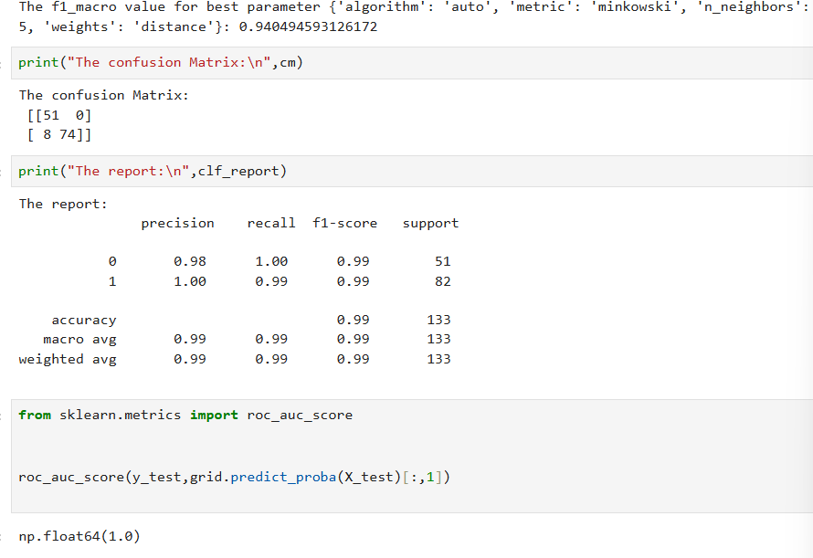

In KNN Grid:

Got 0.99 accuracy

